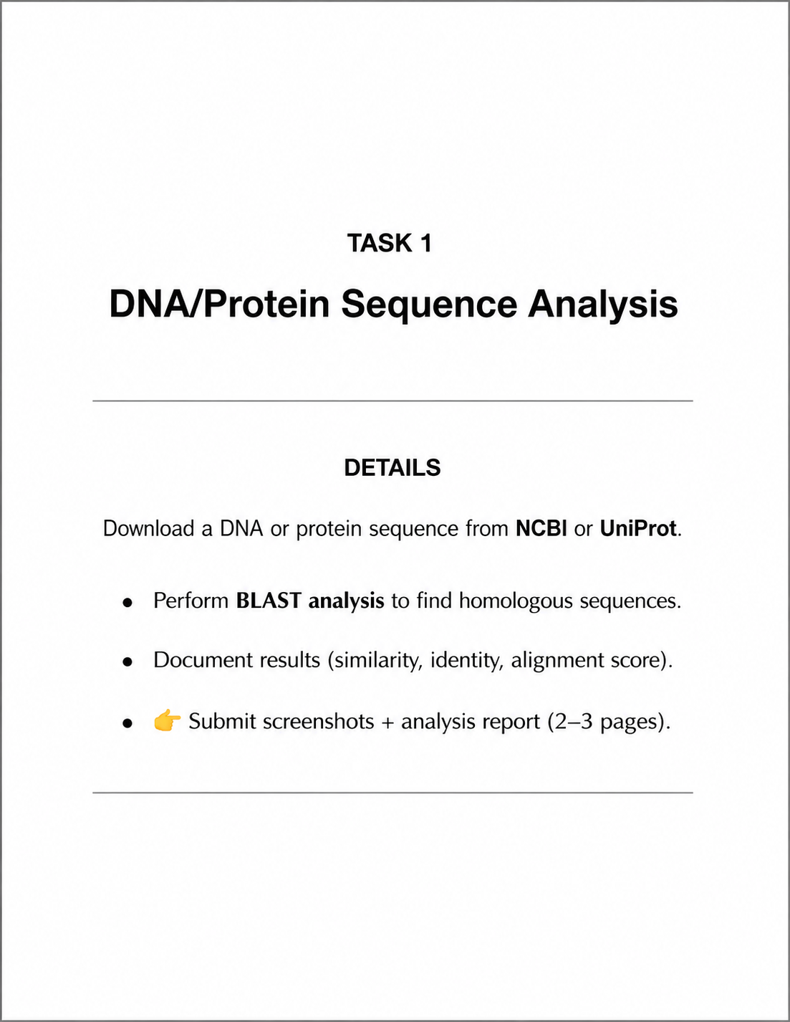
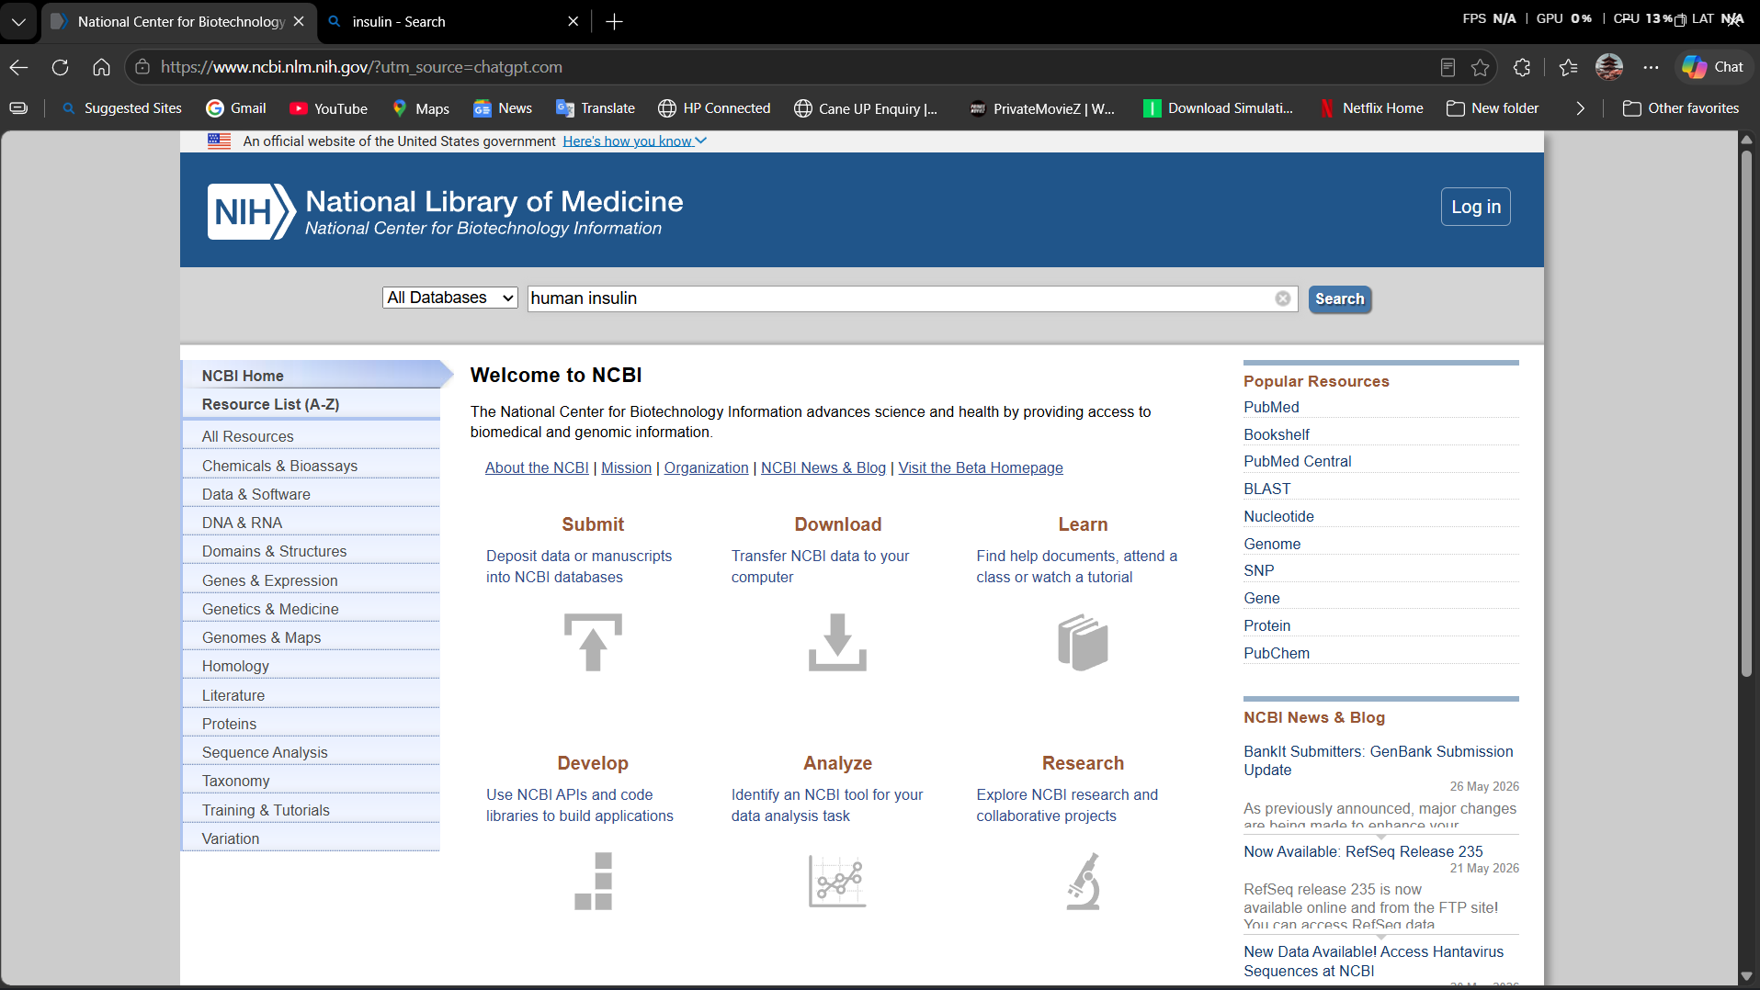
the NCBI website homepage with a search for “human insulin.” It provides biotechnology and medical research databases like PubMed, BLAST, and Genome resources.
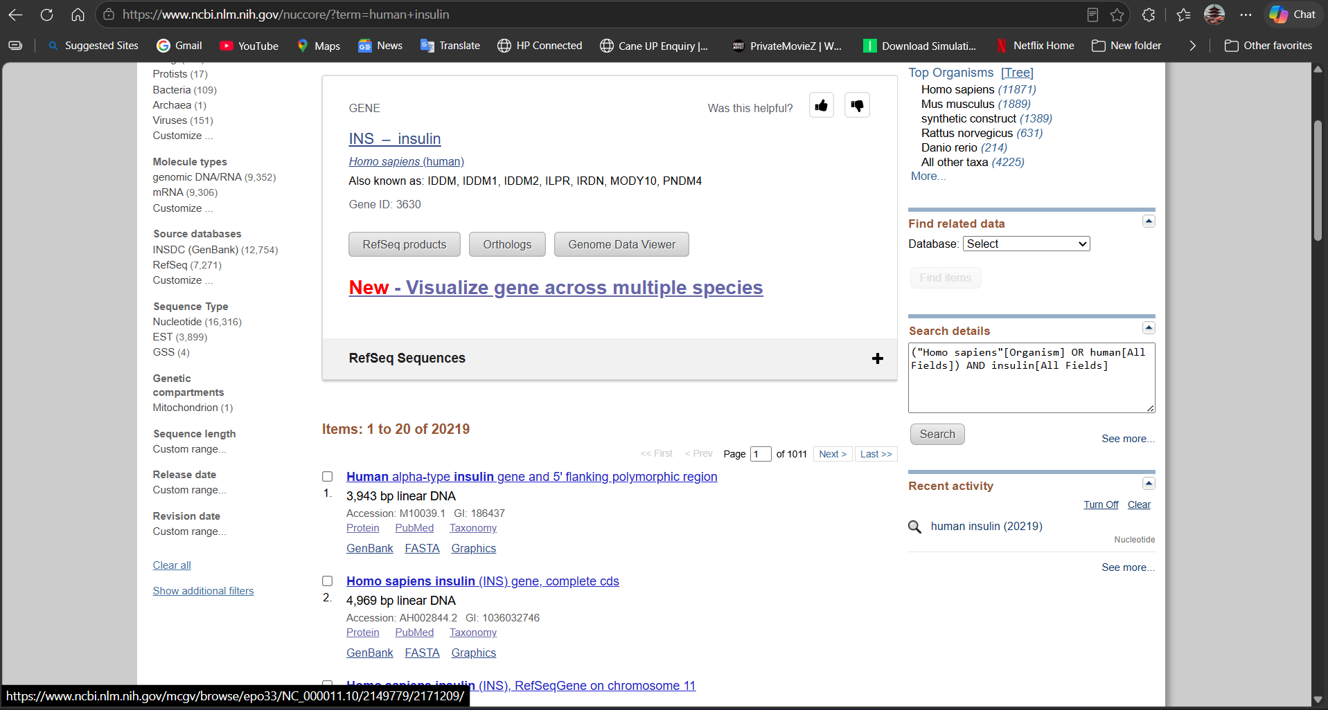
NCBI search results for the human insulin (INS) gene, including DNA sequences and related genetic information from Homo sapiens.

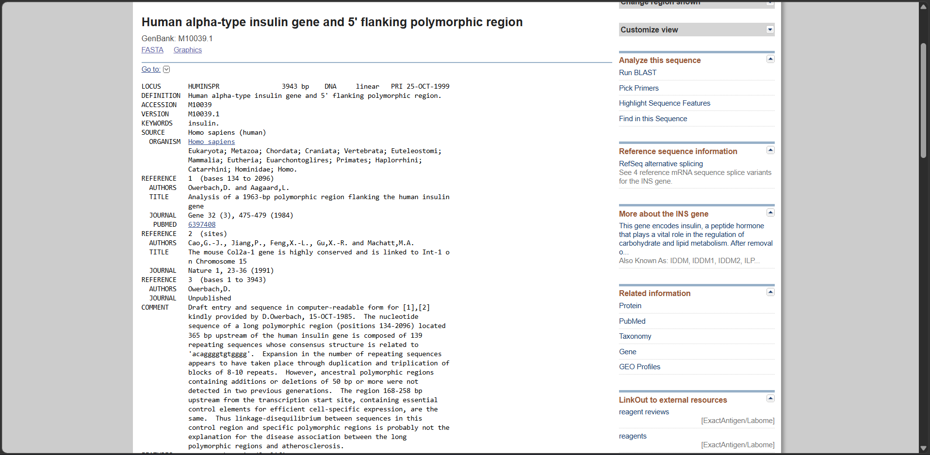
GenBank information for the human alpha-type insulin gene, including its DNA sequence, references, and genetic annotations from NCBI.

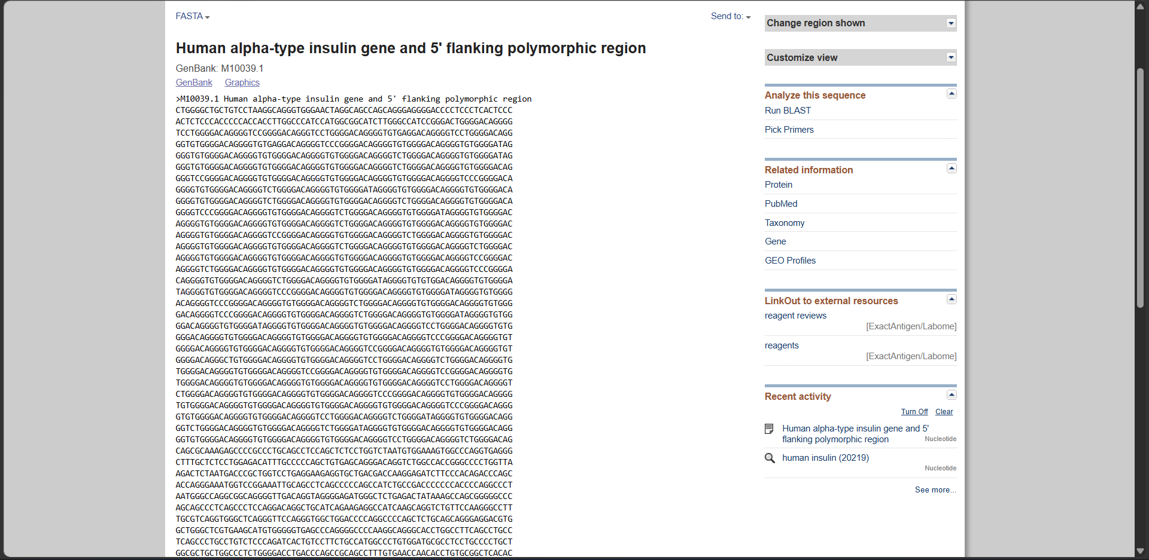
the FASTA format DNA sequence of the human insulin gene region from the NCBI GenBank database.

FASTA

>M10039.1 Human alpha-type insulin gene and 5' flanking polymorphic region
CTGGGGCTGCTGTCCTAAGGCAGGGTGGGAACTAGGCAGCCAGCAGGGAGGGGACCCCTCCCTCACTCCC
ACTCTCCCACCCCCACCACCTTGGCCCATCCATGGCGGCATCTTGGGCCATCCGGGACTGGGGACAGGGG
TCCTGGGGACAGGGGTCCGGGGACAGGGTCCTGGGGACAGGGGTGTGAGGACAGGGGTCCTGGGGACAGG
GGTGTGGGGACAGGGGTGTGAGGACAGGGGTCCCGGGGACAGGGGTGTGGGGACAGGGGTGTGGGGATAG
GGGTGTGGGGACAGGGGTGTGGGGACAGGGGTGTGGGGACAGGGGTCTGGGGACAGGGGTGTGGGGATAG
GGGTGTGGGGACAGGGGTGTGGGGACAGGGGTGTGGGGACAGGGGTCTGGGGACAGGGGTGTGGGGACAG
GGGTCCGGGGACAGGGGTGTGGGGACAGGGGTGTGGGGACAGGGGTGTGGGGACAGGGGTCCCGGGGACA
GGGGTGTGGGGACAGGGGTCTGGGGACAGGGGTGTGGGGATAGGGGTGTGGGGACAGGGGTGTGGGGACA
GGGGTGTGGGGACAGGGGTCTGGGGACAGGGGTGTGGGGACAGGGGTCTGGGGACAGGGGTGTGGGGACA
GGGGTCCCGGGGACAGGGGTGTGGGGACAGGGGTCTGGGGACAGGGGTGTGGGGATAGGGGTGTGGGGAC
AGGGGTGTGGGGACAGGGGTGTGGGGACAGGGGTCTGGGGACAGGGGTGTGGGGACAGGGGTGTGGGGAC
AGGGGTGTGGGGACAGGGGTCCGGGGACAGGGGTGTGGGGACAGGGGTCTGGGGACAGGGGTGTGGGGAC
AGGGGTGTGGGGACAGGGGTGTGGGGACAGGGGTCTGGGGACAGGGGTGTGGGGACAGGGGTCTGGGGAC
AGGGGTGTGGGGACAGGGGTGTGGGGACAGGGGTGTGGGGACAGGGGTGTGGGGACAGGGGTCCGGGGAC
AGGGGTCTGGGGACAGGGGTGTGGGGACAGGGGTGTGGGGACAGGGGTGTGGGGACAGGGGTCCCGGGGA
CAGGGGTGTGGGGACAGGGGTCTGGGGACAGGGGTGTGGGGATAGGGGTGTGTGGACAGGGGTGTGGGGA
TAGGGGTGTGGGGACAGGGGTCCCGGGGACAGGGGTGTGGGGACAGGGGTGTGGGGATAGGGGTGTGGGG
ACAGGGGTCCCGGGGACAGGGGTGTGGGGACAGGGGTCTGGGGACAGGGGTGTGGGGACAGGGGTGTGGG
GACAGGGGTCCCGGGGACAGGGGTGTGGGGACAGGGGTCTGGGGACAGGGGTGTGGGGATAGGGGTGTGG
GGACAGGGGTGTGGGGATAGGGGTGTGGGGACAGGGGTGTGGGGACAGGGGTCCTGGGGACAGGGGTGTG
GGGACAGGGGTGTGGGGACAGGGGTGTGGGGACAGGGGTGTGGGGACAGGGGTCCCGGGGACAGGGGTGT
GGGGACAGGGGTGTGGGGACAGGGGTGTGGGGACAGGGGTCCGGGGACAGGGGTGTGGGGACAGGGGTGT
GGGGACAGGGCTGTGGGGACAGGGGTGTGGGGACAGGGGTCCTGGGGACAGGGGTCTGGGGACAGGGGTG
TGGGGACAGGGGTGTGGGGACAGGGGTCCGGGGACAGGGGTGTGGGGACAGGGGTCCGGGGACAGGGGTG
TGGGGACAGGGGTGTGGGGACAGGGGTGTGGGGACAGGGGTGTGGGGACAGGGGTCCTGGGGACAGGGGT
CTGGGGACAGGGGTGTGGGGACAGGGGTGTGGGGACAGGGGTCCCGGGGACAGGGGTGTGGGGACAGGGG
TGTGGGGACAGGGGTGTGGGGACAGGGGTGTGGGGACAGGGGTGTGGGGACAGGGGTCCCGGGGACAGGG
GTGTGGGGACAGGGGTGTGGGGACAGGGGTCCTGGGGACAGGGGTCTGGGGATAGGGGTGTGGGGACAGG
GGTCTGGGGACAGGGGTGTGGGGACAGGGGTCTGGGGATAGGGGTGTGGGGACAGGGGTGTGGGGACAGG
GGTGTGGGGACAGGGGTGTGGGGACAGGGGTGTGGGGACAGGGGTCCTGGGGACAGGGGTCTGGGGACAG
CAGCGCAAAGAGCCCCGCCCTGCAGCCTCCAGCTCTCCTGGTCTAATGTGGAAAGTGGCCCAGGTGAGGG
CTTTGCTCTCCTGGAGACATTTGCCCCCAGCTGTGAGCAGGGACAGGTCTGGCCACCGGGCCCCTGGTTA
AGACTCTAATGACCCGCTGGTCCTGAGGAAGAGGTGCTGACGACCAAGGAGATCTTCCCACAGACCCAGC
ACCAGGGAAATGGTCCGGAAATTGCAGCCTCAGCCCCCAGCCATCTGCCGACCCCCCCACCCCAGGCCCT
AATGGGCCAGGCGGCAGGGGTTGACAGGTAGGGGAGATGGGCTCTGAGACTATAAAGCCAGCGGGGGCCC
AGCAGCCCTCAGCCCTCCAGGACAGGCTGCATCAGAAGAGGCCATCAAGCAGGTCTGTTCCAAGGGCCTT
TGCGTCAGGTGGGCTCAGGGTTCCAGGGTGGCTGGACCCCAGGCCCCAGCTCTGCAGCAGGGAGGACGTG
GCTGGGCTCGTGAAGCATGTGGGGGTGAGCCCAGGGGCCCCAAGGCAGGGCACCTGGCCTTCAGCCTGCC
TCAGCCCTGCCTGTCTCCCAGATCACTGTCCTTCTGCCATGGCCCTGTGGATGCGCCTCCTGCCCCTGCT
GGCGCTGCTGGCCCTCTGGGGACCTGACCCAGCCGCAGCCTTTGTGAACCAACACCTGTGCGGCTCACAC
CTGGTGGAAGCTCTCTACCTAGTGTGCGGGGAACGAGGCTTCTTCTACACACCCAAGACCCGCCGGGAGG
CAGAGGACCTGCAGGGTGAGCCAACCGCCCATTGCTGCCCCTGGCCGCCCCCAGCCACCCCCTGCTCCTG
GCGCTCCCACCCAGCATGGGCAGAAGGGGGCAGGAGGCTGCCACCCAGCAGGGGGTCAGGTGCACTTTTT
TAAAAAGAAGTTCTCTTGGTCACGTCCTAAAAGTGACCAGCTCCCTGTGGCCCAGTCAGAATCTCAGCCT
GAGGACGGTGTTGGCTTCGGCAGCCCCGAGATACATCAGAGGGTGGGCACGCTCCTCCCTCCACTCGCCC
CTCAAACAAATGCCCCGCAGCCCATTTCTCCACCCTCATTTGATGACCGCAGATTCAAGTGTTTTGTTAA
GTAAAGTCCTGGGTGACCTGGGGTCACAGGGTGCCCCACGCTGCCTGCCTCTGGGCGAACACCCCATCAC
GCCCGGAGGAGGGCGTGGCTGCCTGCCTGAGTGGGCCAGACCCCTGTCGCCAGGCCTCACGGCAGCTCCA
TAGTCAGGAGATGGGGAAGATGCTGGGGACAGGCCCTGGGGAGAAGTACTGGGATCACCTGTTCAGGCTC
CCACTGTGACGCTGCCCCGGGGCGGGGGAAGGAGGTGGGACATGTGGGCGTTGGGGCCTGTAGGTCCACA
CCCACTGTGGGTGACCCTCCCTCTAACCTGGGTCCAGCCCGGCTGGAGATGGGTGGGAGTGTGACCTAGG
GCTGGCGGGCAGGCGGGCACTGTGTCTCCCTGACTGTGTCCTCCTGTGTCCCTCTGCCTCGCCGCTGTTC
CGGAACCTGCTCTGCGCGGCACGTCCTGGCAGTGGGGCAGGTGGAGCTGGGCGGGGGCCCTGGTGCAGGC
AGCCTGCAGCCCTTGGCCCTGGAGGGGTCCCTGCAGAAGCGTGGCATTGTGGAACAATGCTGTACCAGCA
TCTGCTCCCTCTACCAGCTGGAGAACTACTGCAACTAGACGCAGCCCGCAGGCAGCCCCACACCCGCCGC
CTCCTGCACCGAGAGAGATGGAATAAAGCCCTTGAACCAGCCCTGCTGTGCCGTCTGTGTGTCTTGGGGG
CCCTGGGCCAAGCCCCACTTCCC

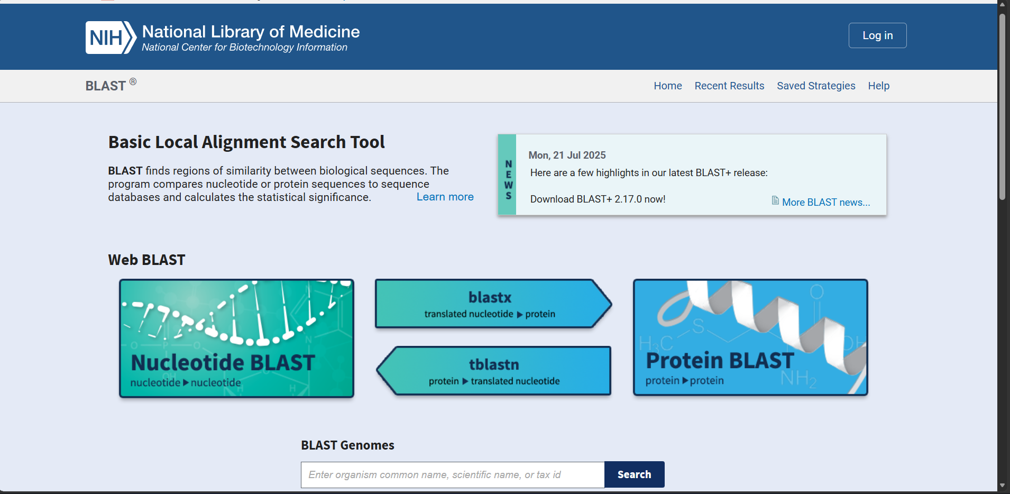
the NCBI BLAST tool page, used to compare DNA or protein sequences and find similarities in biological databases. 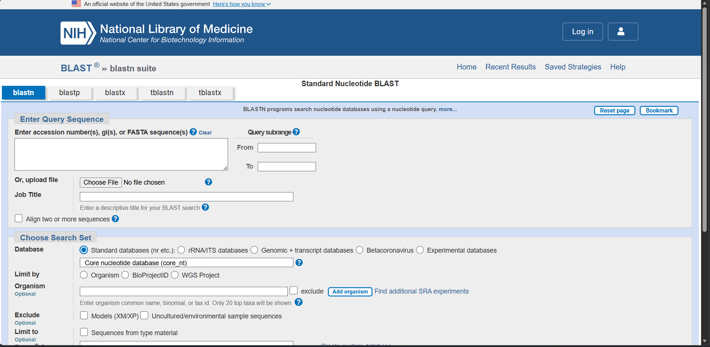the BLASTN search page of NCBI, where users can enter or upload DNA sequences to compare them with nucleotide databases.

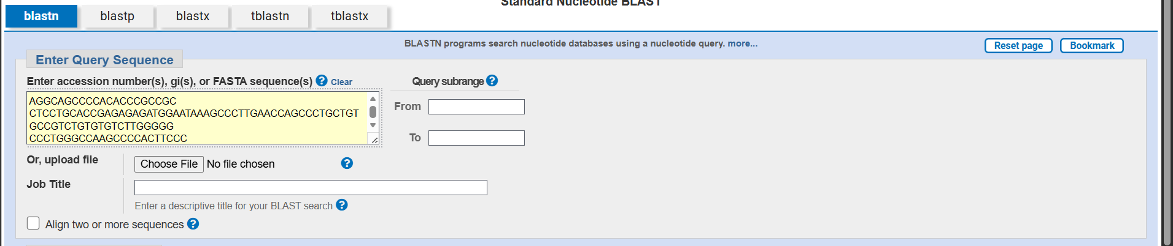

DNA sequence entered into the NCBI BLASTN tool for nucleotide sequence comparison and analysis.

Result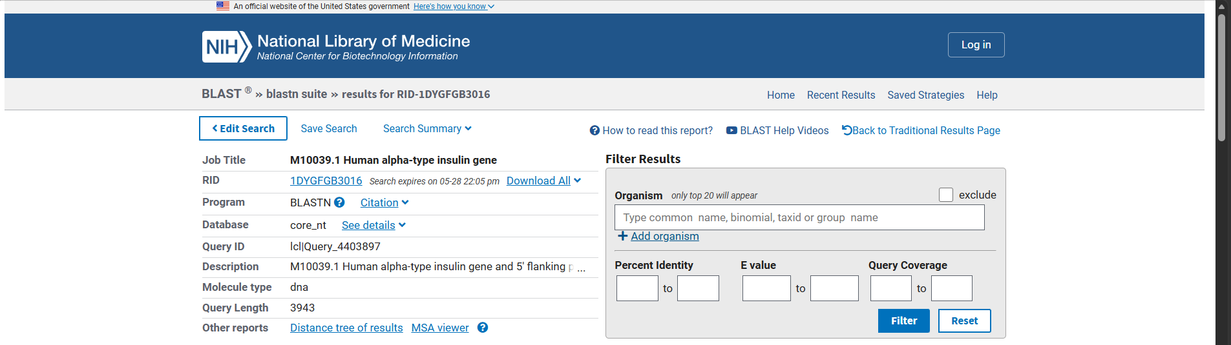the BLASTN results page displaying matches for the human insulin gene sequence searched in the NCBI nucleotide database.
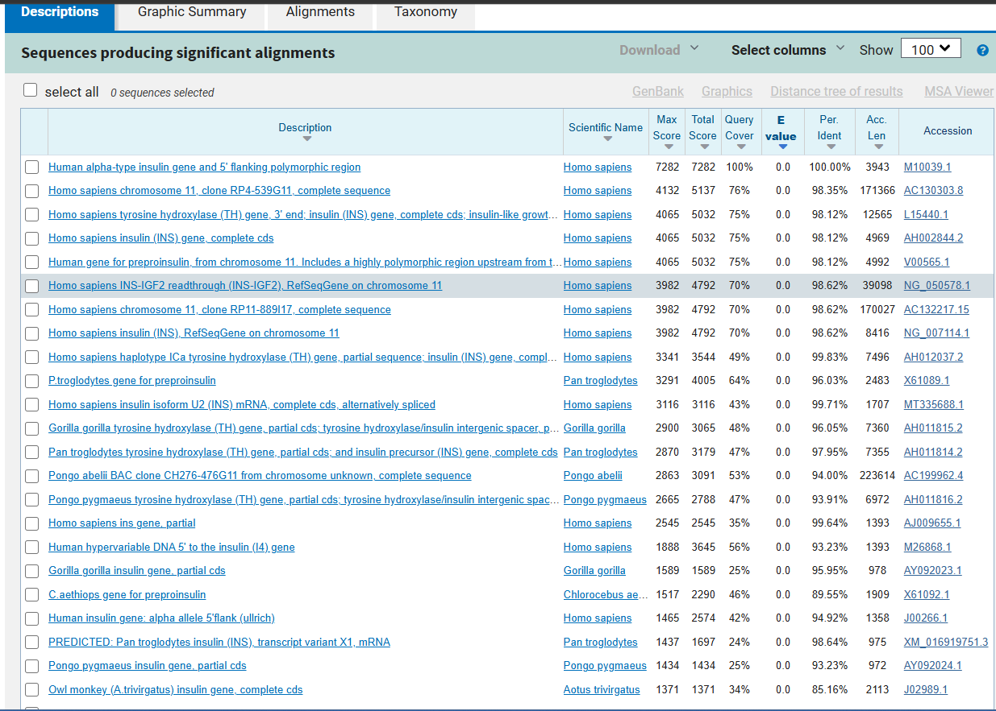
shows significant BLAST alignment results for the human insulin gene, including matching sequences from humans and other species with similarity scores.
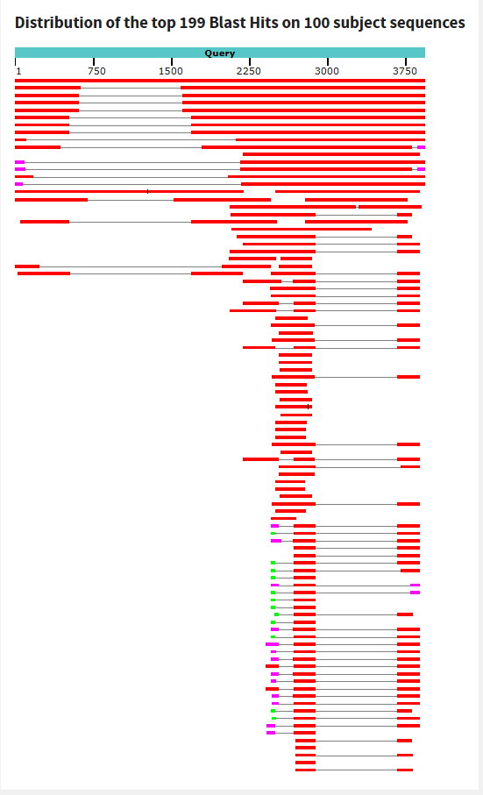\
the graphical summary of BLAST results, displaying the alignment positions and similarity of multiple sequences with the query sequence.

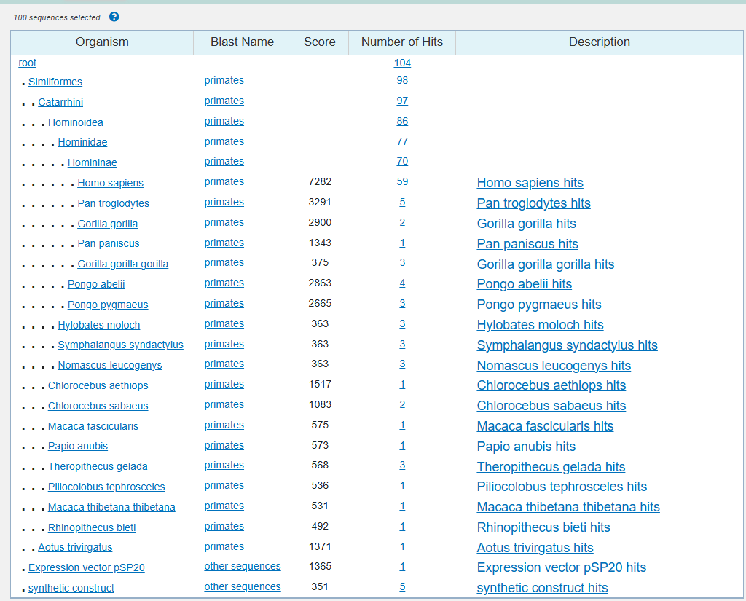

the taxonomy-based BLAST results, listing different organisms with similar insulin gene sequences and their alignment scores.

Alignments

Alignment statistics for match #1
Score | Expect | Identities | Gaps | Strand
7282 bits(3943) | 0.0 | 3943/3943(100%) | 0/3943(0%) | Plus/Plus

Query 1 CTGGGGCTGCTGTCCTAAGGCAGGGTGGGAACTAGGCAGCCAGCAGGGAGGGGACCCCTC 60
||||||||||||||||||||||||||||||||||||||||||||||||||||||||||||
Sbjct 1 CTGGGGCTGCTGTCCTAAGGCAGGGTGGGAACTAGGCAGCCAGCAGGGAGGGGACCCCTC 60

Query 61 CCTCACTCCCACTCTCCCACCCCCACCACCTTGGCCCATCCATGGCGGCATCTTGGGCCA 120
||||||||||||||||||||||||||||||||||||||||||||||||||||||||||||
Sbjct 61 CCTCACTCCCACTCTCCCACCCCCACCACCTTGGCCCATCCATGGCGGCATCTTGGGCCA 120

Query 121 TCCgggactggggacaggggtcctggggacaggggtccggggacagggtcctggggacag 180
||||||||||||||||||||||||||||||||||||||||||||||||||||||||||||
Sbjct 121 TCCGGGACTGGGGACAGGGGTCCTGGGGACAGGGGTCCGGGGACAGGGTCCTGGGGACAG 180

Query 181 gggtgtgaggacaggggtcctggggacaggggtgtggggacaggggtgtgaggacagggg 240
||||||||||||||||||||||||||||||||||||||||||||||||||||||||||||
Sbjct 181 GGGTGTGAGGACAGGGGTCCTGGGGACAGGGGTGTGGGGACAGGGGTGTGAGGACAGGGG 240

Query 241 tcccggggacaggggtgtggggacaggggtgtggggataggggtgtggggacaggggtgt 300
||||||||||||||||||||||||||||||||||||||||||||||||||||||||||||
Sbjct 241 TCCCGGGGACAGGGGTGTGGGGACAGGGGTGTGGGGATAGGGGTGTGGGGACAGGGGTGT 300

Query 301 ggggacaggggtgtggggacaggggtctggggacaggggtgtggggataggggtgtgggg 360
||||||||||||||||||||||||||||||||||||||||||||||||||||||||||||
Sbjct 301 GGGGACAGGGGTGTGGGGACAGGGGTCTGGGGACAGGGGTGTGGGGATAGGGGTGTGGGG 360

Query 361 acaggggtgtggggacaggggtgtggggacaggggtctggggacaggggtgtggggacag 420
||||||||||||||||||||||||||||||||||||||||||||||||||||||||||||
Sbjct 361 ACAGGGGTGTGGGGACAGGGGTGTGGGGACAGGGGTCTGGGGACAGGGGTGTGGGGACAG 420

Query 421 gggtccggggacaggggtgtggggacaggggtgtggggacaggggtgtggggacaggggt 480
||||||||||||||||||||||||||||||||||||||||||||||||||||||||||||
Sbjct 421 GGGTCCGGGGACAGGGGTGTGGGGACAGGGGTGTGGGGACAGGGGTGTGGGGACAGGGGT 480

Query 481 cccggggacaggggtgtggggacaggggtctggggacaggggtgtggggataggggtgtg 540
||||||||||||||||||||||||||||||||||||||||||||||||||||||||||||
Sbjct 481 CCCGGGGACAGGGGTGTGGGGACAGGGGTCTGGGGACAGGGGTGTGGGGATAGGGGTGTG 540

Query 541 gggacaggggtgtggggacaggggtgtggggacaggggtctggggacaggggtgtgggga 600
||||||||||||||||||||||||||||||||||||||||||||||||||||||||||||
Sbjct 541 GGGACAGGGGTGTGGGGACAGGGGTGTGGGGACAGGGGTCTGGGGACAGGGGTGTGGGGA 600

Query 601 caggggtctggggacaggggtgtggggacaggggtcccggggacaggggtgtggggacag 660
||||||||||||||||||||||||||||||||||||||||||||||||||||||||||||
Sbjct 601 CAGGGGTCTGGGGACAGGGGTGTGGGGACAGGGGTCCCGGGGACAGGGGTGTGGGGACAG 660

Query 661 gggtctggggacaggggtgtggggataggggtgtggggacaggggtgtggggacaggggt 720
||||||||||||||||||||||||||||||||||||||||||||||||||||||||||||
Sbjct 661 GGGTCTGGGGACAGGGGTGTGGGGATAGGGGTGTGGGGACAGGGGTGTGGGGACAGGGGT 720

Query 721 gtggggacaggggtctggggacaggggtgtggggacaggggtgtggggacaggggtgtgg 780
||||||||||||||||||||||||||||||||||||||||||||||||||||||||||||
Sbjct 721 GTGGGGACAGGGGTCTGGGGACAGGGGTGTGGGGACAGGGGTGTGGGGACAGGGGTGTGG 780

Query 781 ggacaggggtccggggacaggggtgtggggacaggggtctggggacaggggtgtggggac 840
||||||||||||||||||||||||||||||||||||||||||||||||||||||||||||
Sbjct 781 GGACAGGGGTCCGGGGACAGGGGTGTGGGGACAGGGGTCTGGGGACAGGGGTGTGGGGAC 840

Query 841 aggggtgtggggacaggggtgtggggacaggggtctggggacaggggtgtggggacaggg 900
||||||||||||||||||||||||||||||||||||||||||||||||||||||||||||
Sbjct 841 AGGGGTGTGGGGACAGGGGTGTGGGGACAGGGGTCTGGGGACAGGGGTGTGGGGACAGGG 900

Query 901 gtctggggacaggggtgtggggacaggggtgtggggacaggggtgtggggacaggggtgt 960
||||||||||||||||||||||||||||||||||||||||||||||||||||||||||||
Sbjct 901 GTCTGGGGACAGGGGTGTGGGGACAGGGGTGTGGGGACAGGGGTGTGGGGACAGGGGTGT 960

Query 961 ggggacaggggtccggggacaggggtctggggacaggggtgtggggacaggggtgtgggg 1020
||||||||||||||||||||||||||||||||||||||||||||||||||||||||||||
Sbjct 961 GGGGACAGGGGTCCGGGGACAGGGGTCTGGGGACAGGGGTGTGGGGACAGGGGTGTGGGG 1020

Query 1021 acaggggtgtggggacaggggtcccggggacaggggtgtggggacaggggtctggggaca 1080
||||||||||||||||||||||||||||||||||||||||||||||||||||||||||||
Sbjct 1021 ACAGGGGTGTGGGGACAGGGGTCCCGGGGACAGGGGTGTGGGGACAGGGGTCTGGGGACA 1080

Query 1081 ggggtgtggggataggggtgtgtggacaggggtgtggggataggggtgtggggacagggg 1140
||||||||||||||||||||||||||||||||||||||||||||||||||||||||||||
Sbjct 1081 GGGGTGTGGGGATAGGGGTGTGTGGACAGGGGTGTGGGGATAGGGGTGTGGGGACAGGGG 1140

Query 1141 tcccggggacaggggtgtggggacaggggtgtggggataggggtgtggggacaggggtcc 1200
||||||||||||||||||||||||||||||||||||||||||||||||||||||||||||
Sbjct 1141 TCCCGGGGACAGGGGTGTGGGGACAGGGGTGTGGGGATAGGGGTGTGGGGACAGGGGTCC 1200

Query 1201 cggggacaggggtgtggggacaggggtctggggacaggggtgtggggacaggggtgtggg 1260
||||||||||||||||||||||||||||||||||||||||||||||||||||||||||||
Sbjct 1201 CGGGGACAGGGGTGTGGGGACAGGGGTCTGGGGACAGGGGTGTGGGGACAGGGGTGTGGG 1260

Query 1261 gacaggggtcccggggacaggggtgtggggacaggggtctggggacaggggtgtggggat 1320
||||||||||||||||||||||||||||||||||||||||||||||||||||||||||||
Sbjct 1261 GACAGGGGTCCCGGGGACAGGGGTGTGGGGACAGGGGTCTGGGGACAGGGGTGTGGGGAT 1320

Query 1321 aggggtgtggggacaggggtgtggggataggggtgtggggacaggggtgtggggacaggg 1380
||||||||||||||||||||||||||||||||||||||||||||||||||||||||||||
Sbjct 1321 AGGGGTGTGGGGACAGGGGTGTGGGGATAGGGGTGTGGGGACAGGGGTGTGGGGACAGGG 1380

Query 1381 gtcctggggacaggggtgtggggacaggggtgtggggacaggggtgtggggacaggggtg 1440
||||||||||||||||||||||||||||||||||||||||||||||||||||||||||||
Sbjct 1381 GTCCTGGGGACAGGGGTGTGGGGACAGGGGTGTGGGGACAGGGGTGTGGGGACAGGGGTG 1440

Query 1441 tggggacaggggtcccggggacaggggtgtggggacaggggtgtggggacaggggtgtgg 1500
||||||||||||||||||||||||||||||||||||||||||||||||||||||||||||
Sbjct 1441 TGGGGACAGGGGTCCCGGGGACAGGGGTGTGGGGACAGGGGTGTGGGGACAGGGGTGTGG 1500

Query 1501 ggacaggggtccggggacaggggtgtggggacaggggtgtggggacagggctgtggggac 1560
||||||||||||||||||||||||||||||||||||||||||||||||||||||||||||
Sbjct 1501 GGACAGGGGTCCGGGGACAGGGGTGTGGGGACAGGGGTGTGGGGACAGGGCTGTGGGGAC 1560

Query 1561 aggggtgtggggacaggggtcctggggacaggggtctggggacaggggtgtggggacagg 1620
||||||||||||||||||||||||||||||||||||||||||||||||||||||||||||
Sbjct 1561 AGGGGTGTGGGGACAGGGGTCCTGGGGACAGGGGTCTGGGGACAGGGGTGTGGGGACAGG 1620

Query 1621 ggtgtggggacaggggtccggggacaggggtgtggggacaggggtccggggacaggggtg 1680
||||||||||||||||||||||||||||||||||||||||||||||||||||||||||||
Sbjct 1621 GGTGTGGGGACAGGGGTCCGGGGACAGGGGTGTGGGGACAGGGGTCCGGGGACAGGGGTG 1680

Query 1681 tggggacaggggtgtggggacaggggtgtggggacaggggtgtggggacaggggtcctgg 1740
||||||||||||||||||||||||||||||||||||||||||||||||||||||||||||
Sbjct 1681 TGGGGACAGGGGTGTGGGGACAGGGGTGTGGGGACAGGGGTGTGGGGACAGGGGTCCTGG 1740

Query 1741 ggacaggggtctggggacaggggtgtggggacaggggtgtggggacaggggtcccgggga 1800
||||||||||||||||||||||||||||||||||||||||||||||||||||||||||||
Sbjct 1741 GGACAGGGGTCTGGGGACAGGGGTGTGGGGACAGGGGTGTGGGGACAGGGGTCCCGGGGA 1800

Query 1801 caggggtgtggggacaggggtgtggggacaggggtgtggggacaggggtgtggggacagg 1860
||||||||||||||||||||||||||||||||||||||||||||||||||||||||||||
Sbjct 1801 CAGGGGTGTGGGGACAGGGGTGTGGGGACAGGGGTGTGGGGACAGGGGTGTGGGGACAGG 1860

Query 1861 ggtgtggggacaggggtcccggggacaggggtgtggggacaggggtgtggggacaggggt 1920
||||||||||||||||||||||||||||||||||||||||||||||||||||||||||||
Sbjct 1861 GGTGTGGGGACAGGGGTCCCGGGGACAGGGGTGTGGGGACAGGGGTGTGGGGACAGGGGT 1920

Query 1921 cctggggacaggggtctggggataggggtgtggggacaggggtctggggacaggggtgtg 1980
||||||||||||||||||||||||||||||||||||||||||||||||||||||||||||
Sbjct 1921 CCTGGGGACAGGGGTCTGGGGATAGGGGTGTGGGGACAGGGGTCTGGGGACAGGGGTGTG 1980

Query 1981 gggacaggggtctggggataggggtgtggggacaggggtgtggggacaggggtgtgggga 2040
||||||||||||||||||||||||||||||||||||||||||||||||||||||||||||
Sbjct 1981 GGGACAGGGGTCTGGGGATAGGGGTGTGGGGACAGGGGTGTGGGGACAGGGGTGTGGGGA 2040

Query 2041 caggggtgtggggacaggggtgtggggacaggggtcctggggacaggggtctggggacag 2100
||||||||||||||||||||||||||||||||||||||||||||||||||||||||||||
Sbjct 2041 CAGGGGTGTGGGGACAGGGGTGTGGGGACAGGGGTCCTGGGGACAGGGGTCTGGGGACAG 2100

Query 2101 CAGCGCAAAGAGCCCCGCCCTGCAGCCTCCAGCTCTCCTGGTCTAATGTGGAAAGTGGCC 2160
||||||||||||||||||||||||||||||||||||||||||||||||||||||||||||
Sbjct 2101 CAGCGCAAAGAGCCCCGCCCTGCAGCCTCCAGCTCTCCTGGTCTAATGTGGAAAGTGGCC 2160

Query 2161 CAGGTGAGGGCTTTGCTCTCCTGGAGACATTTGCCCCCAGCTGTGAGCAGGGACAGGTCT 2220
||||||||||||||||||||||||||||||||||||||||||||||||||||||||||||
Sbjct 2161 CAGGTGAGGGCTTTGCTCTCCTGGAGACATTTGCCCCCAGCTGTGAGCAGGGACAGGTCT 2220

Query 2221 GGCCACCGGGCCCCTGGTTAAGACTCTAATGACCCGCTGGTCCTGAGGAAGAGGTGCTGA 2280
||||||||||||||||||||||||||||||||||||||||||||||||||||||||||||
Sbjct 2221 GGCCACCGGGCCCCTGGTTAAGACTCTAATGACCCGCTGGTCCTGAGGAAGAGGTGCTGA 2280

Query 2281 CGACCAAGGAGATCTTCCCACAGACCCAGCACCAGGGAAATGGTCCGGAAATTGCAGCCT 2340
||||||||||||||||||||||||||||||||||||||||||||||||||||||||||||
Sbjct 2281 CGACCAAGGAGATCTTCCCACAGACCCAGCACCAGGGAAATGGTCCGGAAATTGCAGCCT 2340

Query 2341 CAGCCCCCAGCCATCTGCCGAcccccccACCCCAGGCCCTAATGGGCCAGGCGGCAGGGG 2400
||||||||||||||||||||||||||||||||||||||||||||||||||||||||||||
Sbjct 2341 CAGCCCCCAGCCATCTGCCGACCCCCCCACCCCAGGCCCTAATGGGCCAGGCGGCAGGGG 2400

Query 2401 TTGACAGGTAGGGGAGATGGGCTCTGAGACTATAAAGCCAGCGGGGGCCCAGCAGCCCTC 2460
||||||||||||||||||||||||||||||||||||||||||||||||||||||||||||
Sbjct 2401 TTGACAGGTAGGGGAGATGGGCTCTGAGACTATAAAGCCAGCGGGGGCCCAGCAGCCCTC 2460

Query 2461 AGCCCTCCAGGACAGGCTGCATCAGAAGAGGCCATCAAGCAGGTCTGTTCCAAGGGCCTT 2520
||||||||||||||||||||||||||||||||||||||||||||||||||||||||||||
Sbjct 2461 AGCCCTCCAGGACAGGCTGCATCAGAAGAGGCCATCAAGCAGGTCTGTTCCAAGGGCCTT 2520

Query 2521 TGCGTCAGGTGGGCTCAGGGTTCCAGGGTGGCTGGACCCCAGGCCCCAGCTCTGCAGCAG 2580
||||||||||||||||||||||||||||||||||||||||||||||||||||||||||||
Sbjct 2521 TGCGTCAGGTGGGCTCAGGGTTCCAGGGTGGCTGGACCCCAGGCCCCAGCTCTGCAGCAG 2580

Query 2581 GGAGGACGTGGCTGGGCTCGTGAAGCATGTGGGGGTGAGCCCAGGGGCCCCAAGGCAGGG 2640
||||||||||||||||||||||||||||||||||||||||||||||||||||||||||||
Sbjct 2581 GGAGGACGTGGCTGGGCTCGTGAAGCATGTGGGGGTGAGCCCAGGGGCCCCAAGGCAGGG 2640

Query 2641 CACCTGGCCTTCAGCCTGCCTCAGCCCTGCCTGTCTCCCAGATCACTGTCCTTCTGCCAT 2700
||||||||||||||||||||||||||||||||||||||||||||||||||||||||||||
Sbjct 2641 CACCTGGCCTTCAGCCTGCCTCAGCCCTGCCTGTCTCCCAGATCACTGTCCTTCTGCCAT 2700

Query 2701 GGCCCTGTGGATGCGCCTCCTGCCCCTGCTGGCGCTGCTGGCCCTCTGGGGACCTGACCC 2760
||||||||||||||||||||||||||||||||||||||||||||||||||||||||||||
Sbjct 2701 GGCCCTGTGGATGCGCCTCCTGCCCCTGCTGGCGCTGCTGGCCCTCTGGGGACCTGACCC 2760

Query 2761 AGCCGCAGCCTTTGTGAACCAACACCTGTGCGGCTCACACCTGGTGGAAGCTCTCTACCT 2820
||||||||||||||||||||||||||||||||||||||||||||||||||||||||||||
Sbjct 2761 AGCCGCAGCCTTTGTGAACCAACACCTGTGCGGCTCACACCTGGTGGAAGCTCTCTACCT 2820

Query 2821 AGTGTGCGGGGAACGAGGCTTCTTCTACACACCCAAGACCCGCCGGGAGGCAGAGGACCT 2880
||||||||||||||||||||||||||||||||||||||||||||||||||||||||||||
Sbjct 2821 AGTGTGCGGGGAACGAGGCTTCTTCTACACACCCAAGACCCGCCGGGAGGCAGAGGACCT 2880

Query 2881 GCAGGGTGAGCCAACCGCCCATTGCTGCCCCTGGCCGCCCCCAGCCACCCCCTGCTCCTG 2940
||||||||||||||||||||||||||||||||||||||||||||||||||||||||||||
Sbjct 2881 GCAGGGTGAGCCAACCGCCCATTGCTGCCCCTGGCCGCCCCCAGCCACCCCCTGCTCCTG 2940

Query 2941 GCGCTCCCACCCAGCATGGGCAGAAGGGGGCAGGAGGCTGCCACCCAGCAGGGGGTCAGG 3000
||||||||||||||||||||||||||||||||||||||||||||||||||||||||||||
Sbjct 2941 GCGCTCCCACCCAGCATGGGCAGAAGGGGGCAGGAGGCTGCCACCCAGCAGGGGGTCAGG 3000

Query 3001 TGCACTTTTTTAAAAAGAAGTTCTCTTGGTCACGTCCTAAAAGTGACCAGCTCCCTGTGG 3060
||||||||||||||||||||||||||||||||||||||||||||||||||||||||||||
Sbjct 3001 TGCACTTTTTTAAAAAGAAGTTCTCTTGGTCACGTCCTAAAAGTGACCAGCTCCCTGTGG 3060

Query 3061 CCCAGTCAGAATCTCAGCCTGAGGACGGTGTTGGCTTCGGCAGCCCCGAGATACATCAGA 3120
||||||||||||||||||||||||||||||||||||||||||||||||||||||||||||
Sbjct 3061 CCCAGTCAGAATCTCAGCCTGAGGACGGTGTTGGCTTCGGCAGCCCCGAGATACATCAGA 3120

Query 3121 GGGTGGGCACGCTCCTCCCTCCACTCGCCCCTCAAACAAATGCCCCGCAGCCCATTTCTC 3180
||||||||||||||||||||||||||||||||||||||||||||||||||||||||||||
Sbjct 3121 GGGTGGGCACGCTCCTCCCTCCACTCGCCCCTCAAACAAATGCCCCGCAGCCCATTTCTC 3180

Query 3181 CACCCTCATTTGATGACCGCAGATTCAAGTGTTTTGTTAAGTAAAGTCCTGGGTGACCTG 3240
||||||||||||||||||||||||||||||||||||||||||||||||||||||||||||
Sbjct 3181 CACCCTCATTTGATGACCGCAGATTCAAGTGTTTTGTTAAGTAAAGTCCTGGGTGACCTG 3240

Query 3241 GGGTCACAGGGTGCCCCACGCTGCCTGCCTCTGGGCGAACACCCCATCACGCCCGGAGGA 3300
||||||||||||||||||||||||||||||||||||||||||||||||||||||||||||
Sbjct 3241 GGGTCACAGGGTGCCCCACGCTGCCTGCCTCTGGGCGAACACCCCATCACGCCCGGAGGA 3300

Query 3301 GGGCGTGGCTGCCTGCCTGAGTGGGCCAGACCCCTGTCGCCAGGCCTCACGGCAGCTCCA 3360
||||||||||||||||||||||||||||||||||||||||||||||||||||||||||||
Sbjct 3301 GGGCGTGGCTGCCTGCCTGAGTGGGCCAGACCCCTGTCGCCAGGCCTCACGGCAGCTCCA 3360

Query 3361 TAGTCAGGAGATGGGGAAGATGCTGGGGACAGGCCCTGGGGAGAAGTACTGGGATCACCT 3420
||||||||||||||||||||||||||||||||||||||||||||||||||||||||||||
Sbjct 3361 TAGTCAGGAGATGGGGAAGATGCTGGGGACAGGCCCTGGGGAGAAGTACTGGGATCACCT 3420

Query 3421 GTTCAGGCTCCCACTGTGACGCTGCCCCGGGGCGGGGGAAGGAGGTGGGACATGTGGGCG 3480
||||||||||||||||||||||||||||||||||||||||||||||||||||||||||||
Sbjct 3421 GTTCAGGCTCCCACTGTGACGCTGCCCCGGGGCGGGGGAAGGAGGTGGGACATGTGGGCG 3480

Query 3481 TTGGGGCCTGTAGGTCCACACCCACTGTGGGTGACCCTCCCTCTAACCTGGGTCCAGCCC 3540
||||||||||||||||||||||||||||||||||||||||||||||||||||||||||||
Sbjct 3481 TTGGGGCCTGTAGGTCCACACCCACTGTGGGTGACCCTCCCTCTAACCTGGGTCCAGCCC 3540

Query 3541 GGCTGGAGATGGGTGGGAGTGTGACCTAGGGCTGGCGGGCAGGCGGGCACTGTGTCTCCC 3600
||||||||||||||||||||||||||||||||||||||||||||||||||||||||||||
Sbjct 3541 GGCTGGAGATGGGTGGGAGTGTGACCTAGGGCTGGCGGGCAGGCGGGCACTGTGTCTCCC 3600

Query 3601 TGACTGTGTCCTCCTGTGTCCCTCTGCCTCGCCGCTGTTCCGGAACCTGCTCTGCGCGGC 3660
||||||||||||||||||||||||||||||||||||||||||||||||||||||||||||
Sbjct 3601 TGACTGTGTCCTCCTGTGTCCCTCTGCCTCGCCGCTGTTCCGGAACCTGCTCTGCGCGGC 3660

Query 3661 ACGTCCTGGCAGTGGGGCAGGTGGAGCTGGGCGGGGGCCCTGGTGCAGGCAGCCTGCAGC 3720
||||||||||||||||||||||||||||||||||||||||||||||||||||||||||||
Sbjct 3661 ACGTCCTGGCAGTGGGGCAGGTGGAGCTGGGCGGGGGCCCTGGTGCAGGCAGCCTGCAGC 3720

Query 3721 CCTTGGCCCTGGAGGGGTCCCTGCAGAAGCGTGGCATTGTGGAACAATGCTGTACCAGCA 3780
||||||||||||||||||||||||||||||||||||||||||||||||||||||||||||
Sbjct 3721 CCTTGGCCCTGGAGGGGTCCCTGCAGAAGCGTGGCATTGTGGAACAATGCTGTACCAGCA 3780

Query 3781 TCTGCTCCCTCTACCAGCTGGAGAACTACTGCAACTAGACGCAGCCCGCAGGCAGCCCCA 3840
||||||||||||||||||||||||||||||||||||||||||||||||||||||||||||
Sbjct 3781 TCTGCTCCCTCTACCAGCTGGAGAACTACTGCAACTAGACGCAGCCCGCAGGCAGCCCCA 3840

Query 3841 CACCCGCCGCCTCCTGCACCGAGAGAGATGGAATAAAGCCCTTGAACCAGCCCTGCTGTG 3900
||||||||||||||||||||||||||||||||||||||||||||||||||||||||||||
Sbjct 3841 CACCCGCCGCCTCCTGCACCGAGAGAGATGGAATAAAGCCCTTGAACCAGCCCTGCTGTG 3900

Query 3901 CCGTCTGTGTGTCTTGGGGGCCCTGGGCCAAGCCCCACTTCCC 3943
|||||||||||||||||||||||||||||||||||||||||||
Sbjct 3901 CCGTCTGTGTGTCTTGGGGGCCCTGGGCCAAGCCCCACTTCCC 3943

